**Assessment one**

This word documentation includes project notes.

Project Notes

This ABM (Agent Based Model) collates localised environments, imported from online sources (via web scrapping – code found in 2.0 of the script) and a CSV file importation that allows for agents that have been randomised to move “eating” the environment. These concepts of modelling are most suitable for ecology studies, however, when creating randomised values, it encourages the use of risk or scenario modelling per se. The end product of the ABM model is to produce a GUI (Graphical User Interface) whereby the user can call upon the script to commence the model. The GUI is a combination of both matplotlib.plot outputs from agent positioning (moving) and imported environment.

As mentioned in my readme.txt file, the model is reliant on three files (agent.py, agentframework.py and in.txt) to be active/ in same folder domain. When loading spyder, ensure the IPython Console graphics are “Inline” not automatic. Otherwise, this shall produce an inactive GUI and will not work as intended.

Below contains screenshot evidence for (1) how to run the model and (2) what is expected once the user starts the GUI.

Figure one – Expected Model window output when code is run before user commences model.

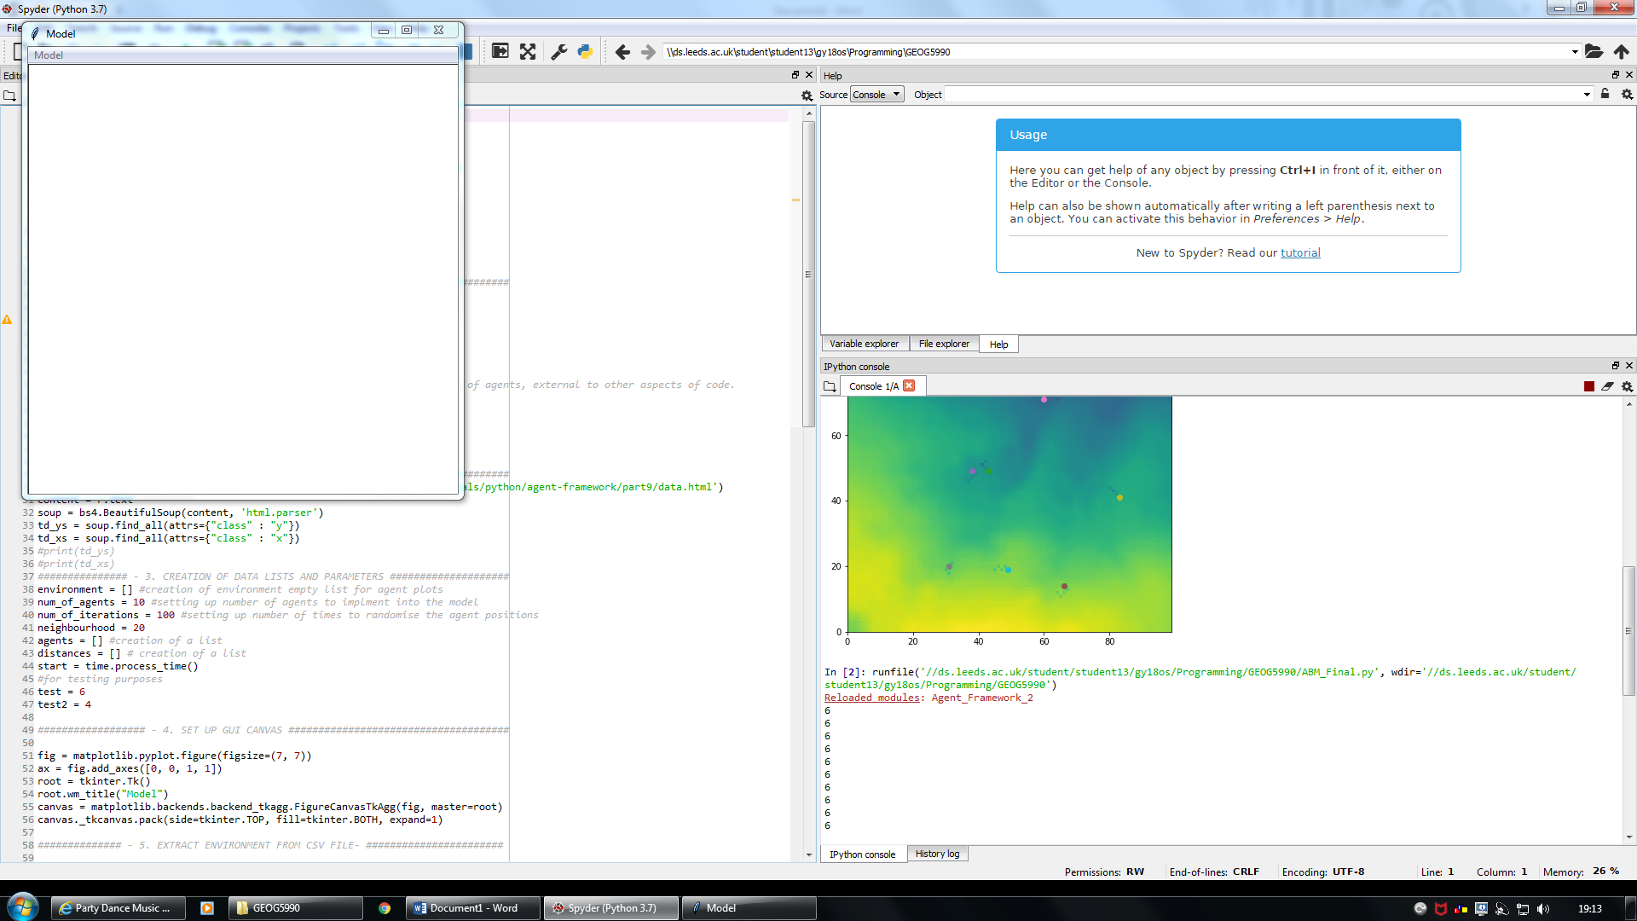

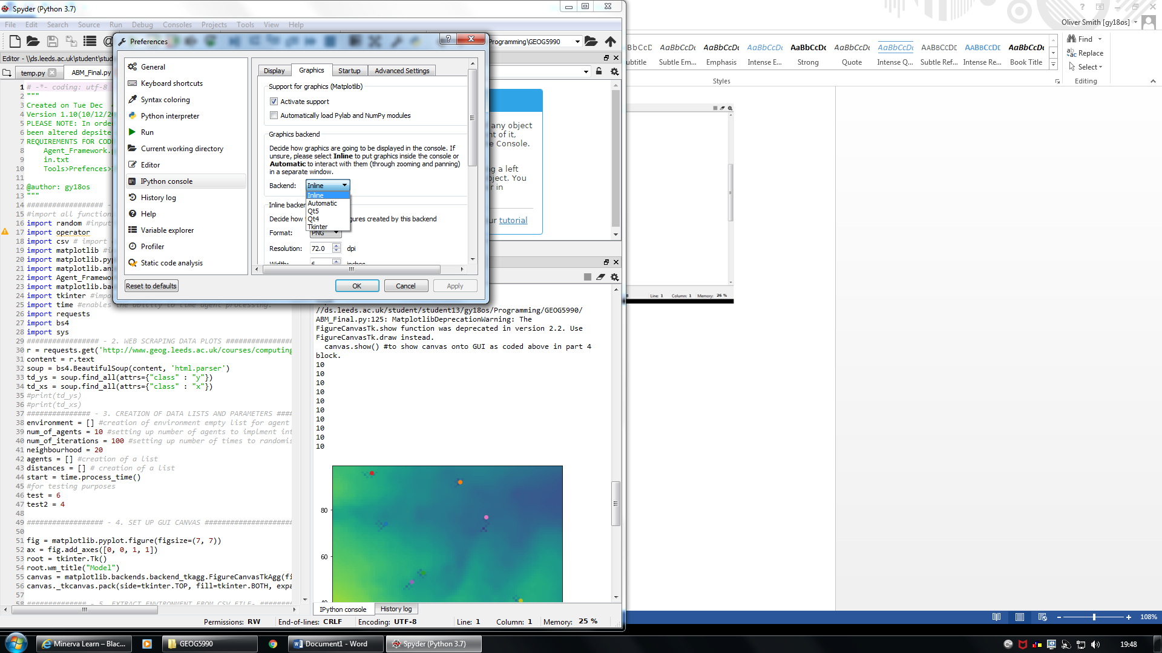

Figure two – A visual diagram to show how to commence the GUI.

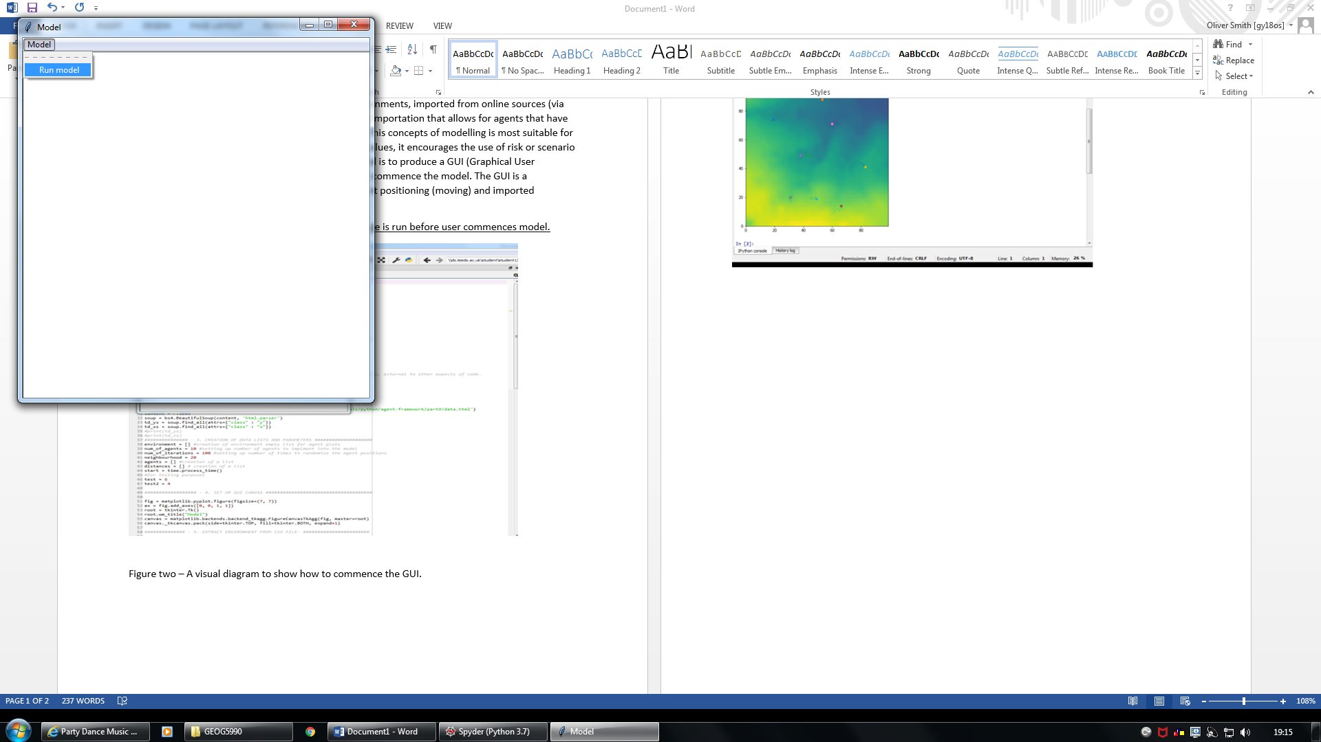

Figure three – A still image of the GUI once user requests the model to start.

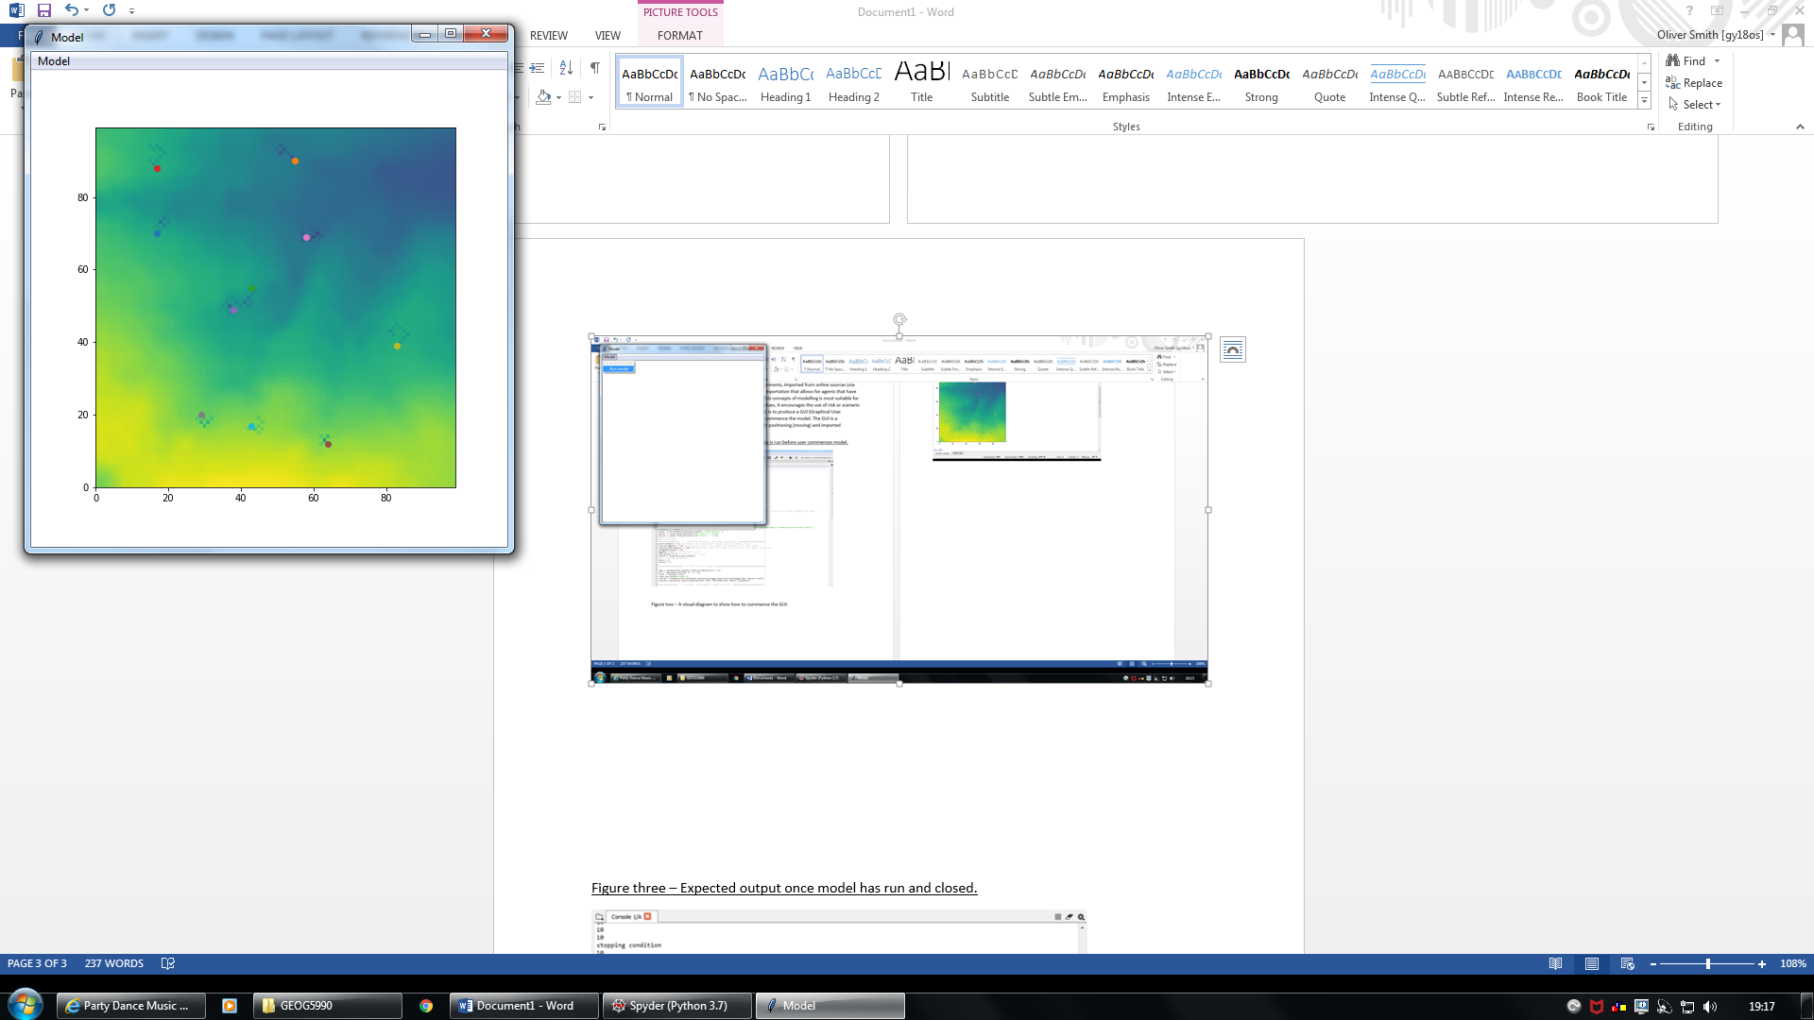

Figure four – Expected output once model has run and closed (Shows agent movements)

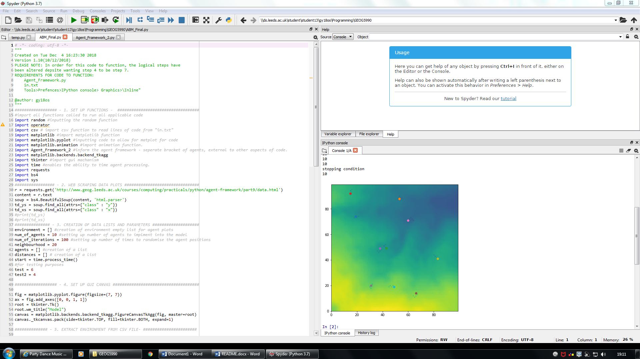

“stopping condition” implies the criteria of the model to stop has been met.